1-preface

1.1-Document purpose:

The purpose of this document is to provide complete and detailed specifications of the Movie Recommendation System.

The document will provide an overview of the system in the first section, then each part will be explained in detail in the second and third sections.

1.2-Target users:

This document is intended to be used by Dr. Manal Shoman

1.3-Revision history:

|  |  |  |  |
| --- | --- | --- | --- |
| **Version** | **Author** | **Description** | **Date** |
| 0.1 | Omar | Initial | 5-6-2020 |
| 0.2 | Omar | Register Functionality | 5-6-2020 |
| 0.3 | Omar | Updating Database | 5-6-2020 |
| 0.4 | Mohab | Login Functionality | 5-6-2020 |
|  | Mohab | System logs functionality | 5-6-2020 |
| 0.5 | Mohab | Update database | 5-6-2020 |
| 0.7 | Mikel | Update database | 5-6-2020 |
| 0.8 | Mikel | Reports functionality | 5-6-2020 |

2-Introduction

2.1-Purpose

The movie recommendations system is for movie lovers and aims to facilitate the process of finding good movies based on ratings and reviews of these movies, with additional feature of viewing actors and searching for them.

2.2-Scope

The movie recommendation system is a software that will allow registered users to search for movies in our database, rate and review those movies, they can also search for actors and find information like their date of birth and age.

While on the other hand admins can add/delete/update movies, add/delete actors and view reports about the movie database and view system logs that include the operation of insertion/update/deletion in the database.

2.3- Overview

This document is organized as follows: first, an overview description of the software and its high level functions are presented (section 2.1 and 2.2). Section 2.3 states types of users who can use our software. Then a list of general constraints that should be followed, assumptions and dependencies are presented in sections 2.4 and 2.5. Section 2.6 shows future works that should be done.

Section 3 in the document provides a detailed description of the system functions and requirements. Finally, section 4 presents some helping information and diagrams that will facilitate the understanding of this document.

3-Glossary

3.1- Acronyms, definitions and abbreviations.

4-System Users

3.1- System stakeholders

* System Engineers
* Responsible for requirements gathering
* Responsible for development
* Responsible for deployment and support
* Admins
* Add/Update/Delete movies
* Add/Delete actors
* View System logs
* View Reports
* Registered User
* Browse movies
* Rate movies
* Review movies
* Browse actors

5-User Requirements definitions

5.1-System Functions

* Create account for regular user (Registering)
* Login to the account
* Views movies/search/sort
* View movie’s review/rating
* Add/Update/Delete movies
* Add/Delete actors
* View system logs
* View reports

5.2-Constraints

* Privacy
  + All user data is confidential and are kept from other users/admins.
* Hardware Limitations
  + Single server Deployment issues.

6-System Architecture

7-System Functional requirements

7.1-Register new users

* New user can register to create their own account by entering a username between 3 and 12 character and password between 3 and 6 characters.

7.2-User Login

* Registered user can login using his/her username and password that was entered during registration phase.

7.3-Admin Login

* Admin can Login by putting admin_ before his username so that the system knows the it is an admin information, then enters his/her password.

7.4-View movies

* Registered user/admin can view/search/sort all the movies recorded in our database.

7.5-View Ratings and Reviews

* Registered user/admin can view other users ratings and reviews for a selected movie.

7.6-Submit Ratings and Reviews

* Registered users can submit a review and a rating for a selected movie and other users will be able to view it.

7.7-View Actors

* Registered user/admin can view/search/sort all actors in the database.

7.8-Add actors

* Registered admin can add actors to the database.

7.9-Delete actors

* Registered admin can delete actors from the database.

7.10-Add/Update movies

* Registered admin can add/update movies to the database.

7.11-Delete movies

* Registered admin can delete movies from the database.

7.12-View System logs

* Registered admin can view logs from the database to know the latest operations (Insertion/update/delete) done by a user/admin and debug the system if a bug occurred in the future.

7.13-View Reports

* Registered admin can view reports about the number of movies in each genre in a database and the number of movies of a certain rating.

8-Interface requirements

8.1-User Interface

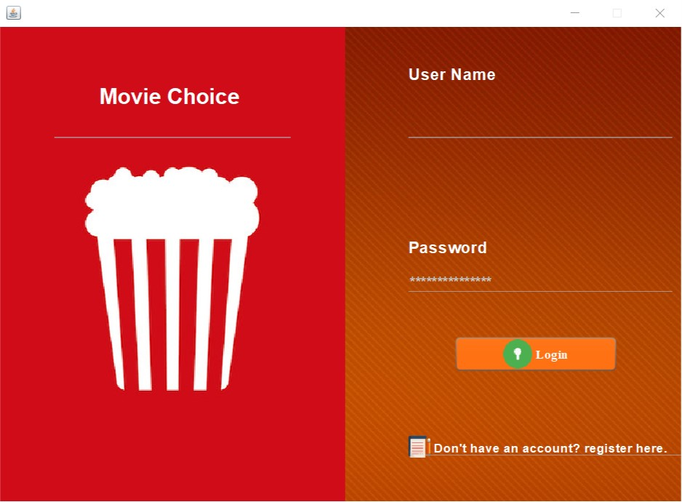

Figure 1:Login Page

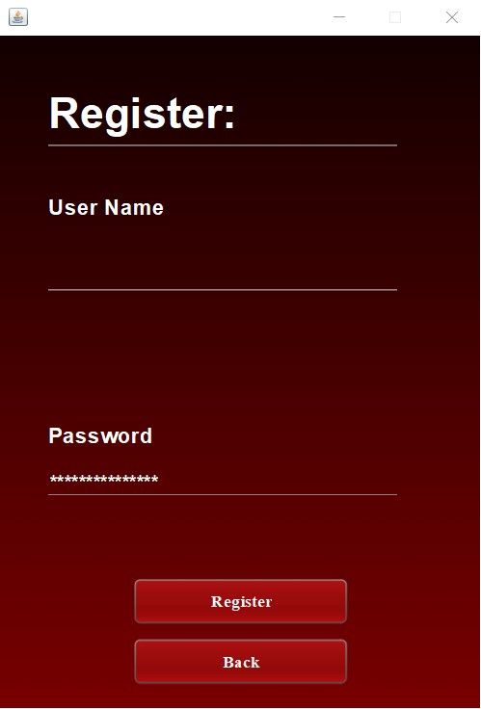

Figure 2: Registration Page

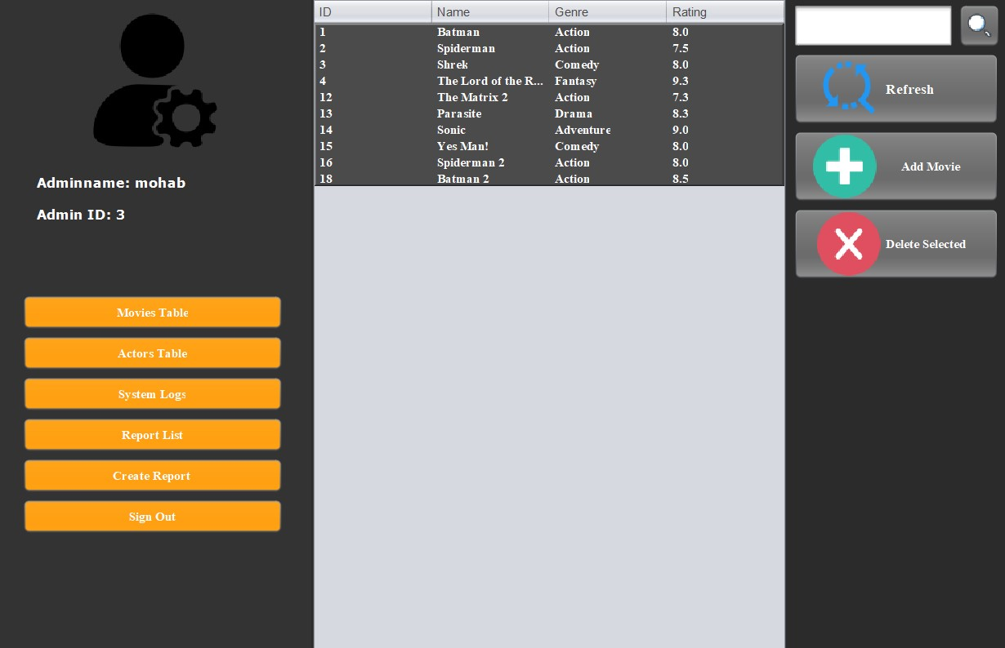

Figure 3: Admin Navigation Page (Movie Table Selected)

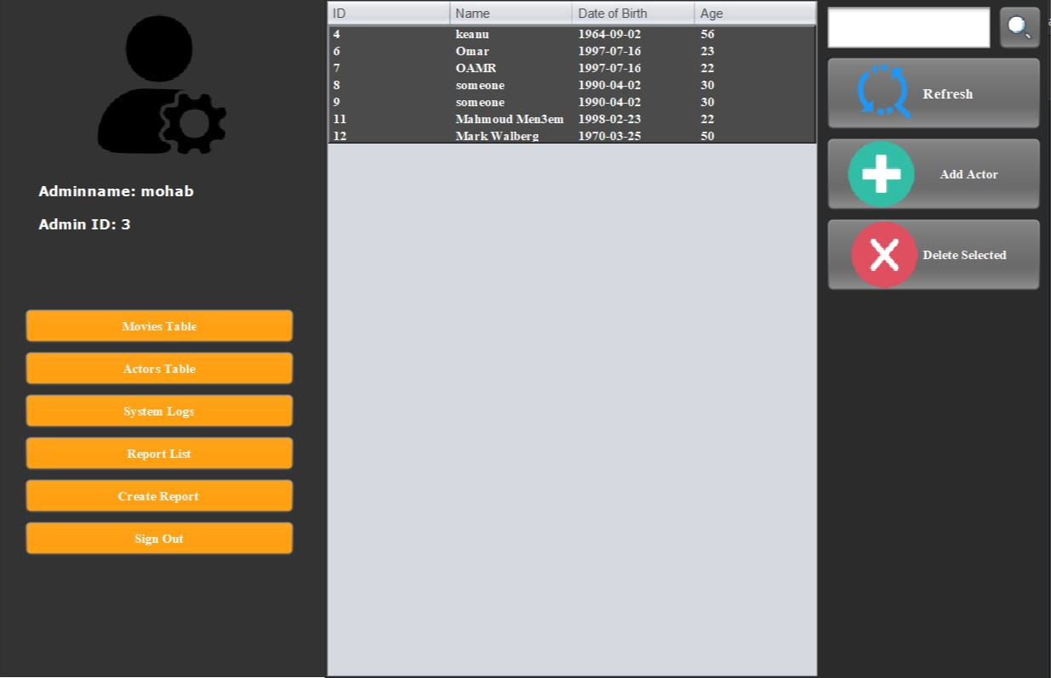

Figure 4: Admin Navigation Page (Actors Table Selected)

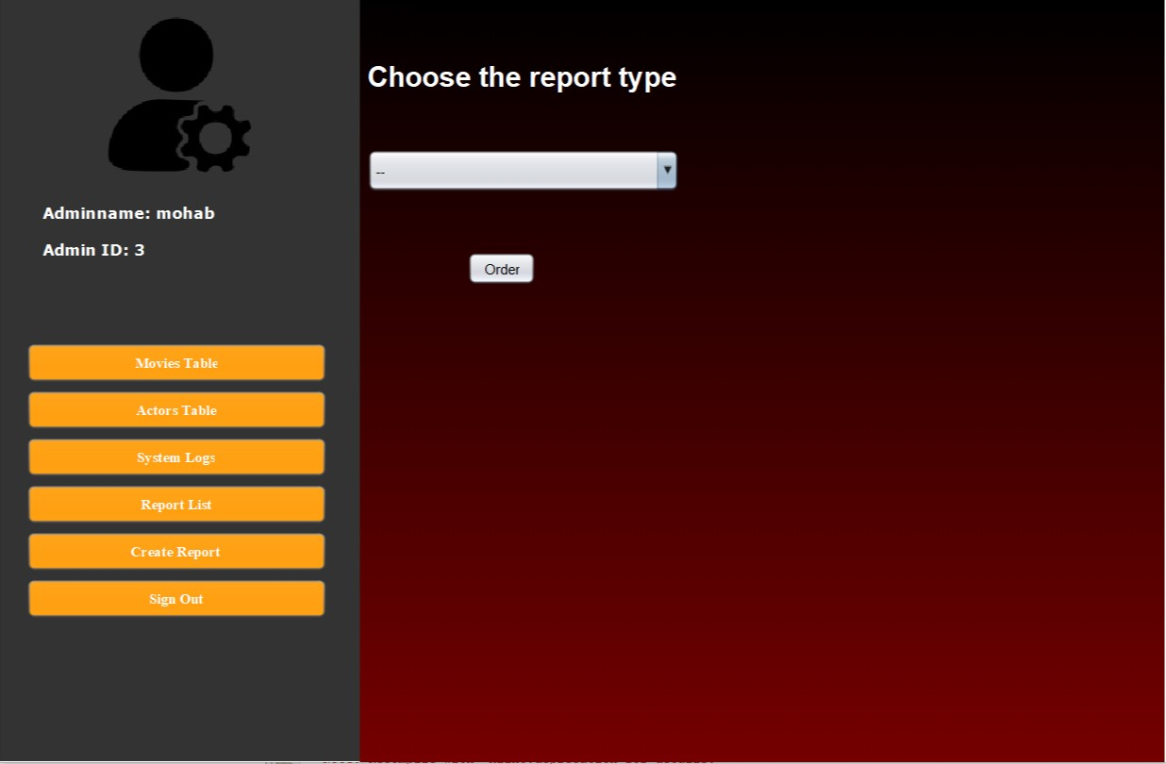

Figure 5:Admin Navigation Page (Report List Selected)

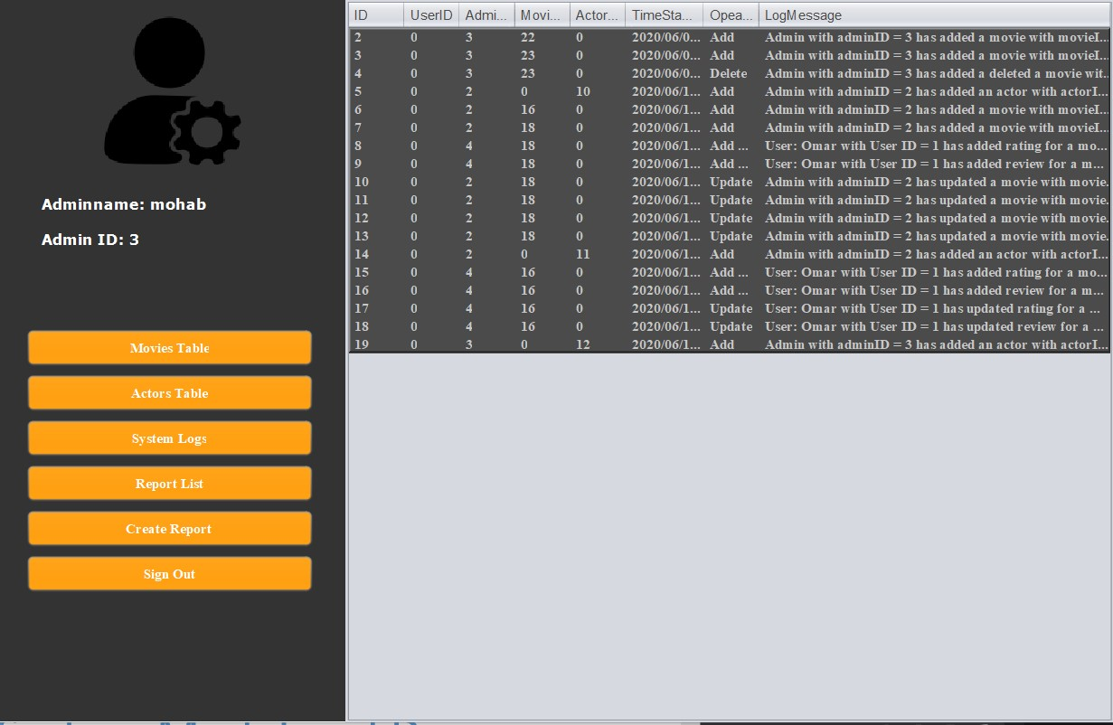

Figure 6: Admin Navigation Page (System Logs Selected)

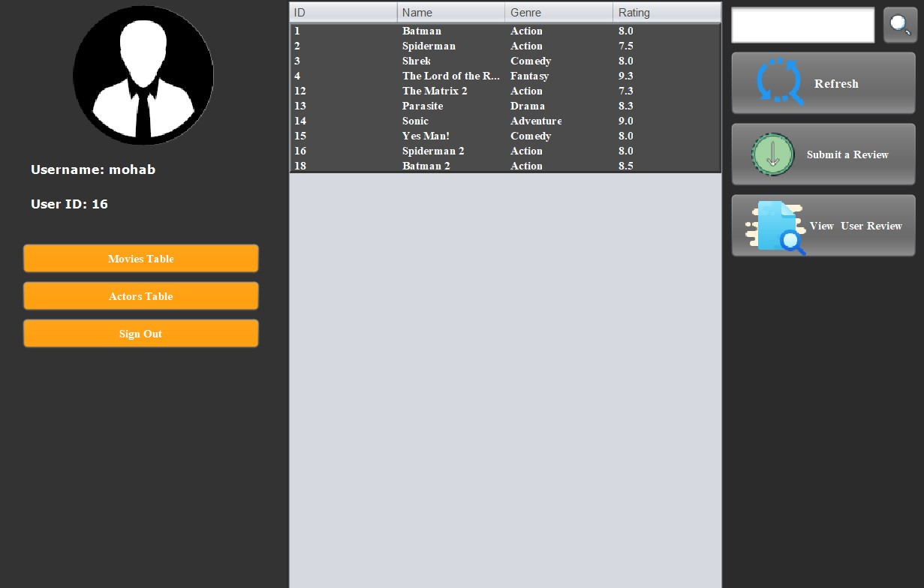

Figure 7: User Navigation Page (Movie Table Selected)

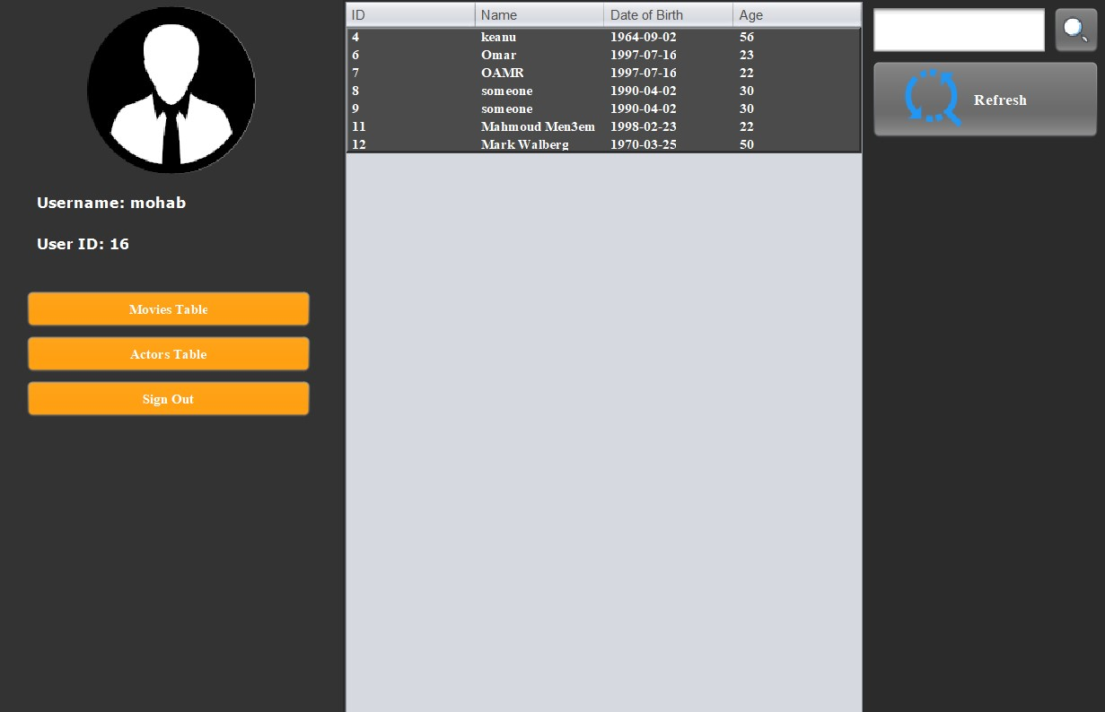

Figure 8: User Navigation Page (Actors Table Selected)

9- Non-functional requirements

10-System Model and Diagrams

10.1-Use Case diagram

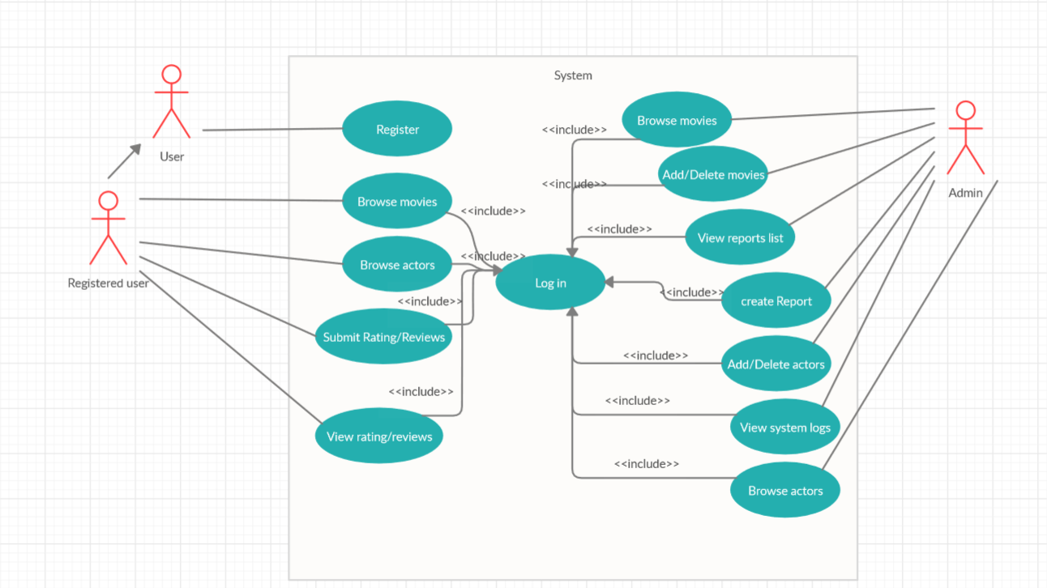

11-System Evolution

12-Time plan